Reading 2

Lonneke Lammers   
10371672

Read the following chapters and answer the accompanying questions. Save your answers in Readings2.pdf and push it to GitHub.

* S. Carpendale, “[Considering Visual Variables as a Basis for Information Visualisation](http://cdn.mprog.nl/dataviz/excerpts/w2/Carpendale_Considering_Visual_Variables.pdf)”.
* W. S. Cleveland and R. McGill, “[Graphical Perception: Theory, Experimentation, and Application to the Development of Graphical Methods](http://cdn.mprog.nl/dataviz/excerpts/w2/Cleveland_Graphical_Perception_Theory.pdf)”, Journal of the American Statistical Association, vol. 79, no. 387, pp. 531–554, 1984.
* (https://cdn.mprog.nl/dataviz/excerpts/w1/Munzner_Nested_Process_Model_for_Visualization_Design.pdf )

Questions

1. Find a visualization not discussed in class or used in a homework and answer the following questions pertaining to that visualization. Attach the visualization as a screenshot in your submission.
2. Consider Bertin’s characterization of visual variables (position, size, shape, value, color, orientation, and texture). Pick 2 of Bertin’s visual variables, and discuss them in relation to your visualization.
3. Munzner proposed a nested model for visualization design and validation. Discuss/validate your visualization with respect to domain problem characterization and data/operation abstraction design.
4. Based on Cleveland and McGill’s results, does your visualization embody good practices (i.e. can people accurately perform the tasks based on the encodings?)
5. Do you agree that visualization is a functional art? Explain.
6. Ask yourself what the designer is trying to convey and think of three to four possible tasks this visualization should help you with. Does the visualization achieve any of your tasks? (To view an example, see Albert Cairo, pages 26-­28.)

From: http://blog.hubspot.com/marketing/great-data-visualization-examples

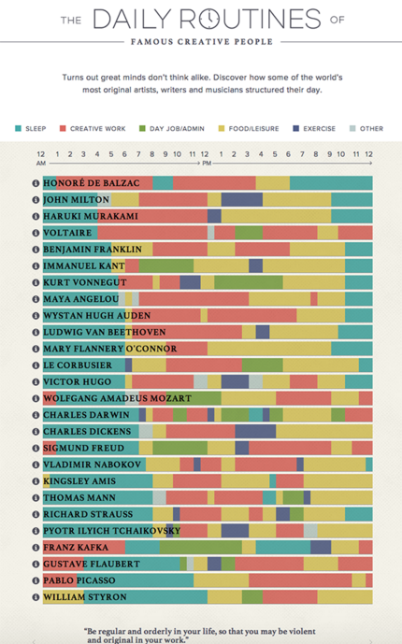

Answers

1. See above, the visualisation of the Daily Routines of famous creative people.
2. Bertin describes these visual variables:

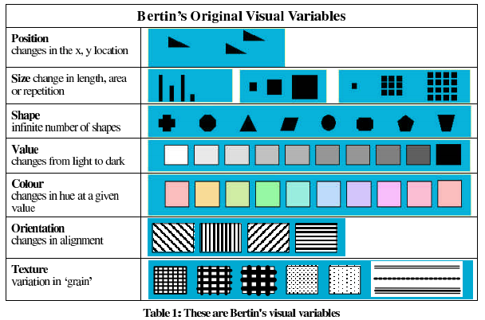

In my visualization you see **size** changes in length, where length is the time in hours.   
The visual variable *selective* is important here, as one colour with a meaning can stand out in one of the lines of the creative people. For example, the dark-purple rectangle in John Milton’s line is outstanding in this visualization, where a lot of the other creative people don’t do exercise.   
The visual variable *order* is a notable variable. For instance if you compare Thoman Mann with Pable Picasso, they have a real different order in filling in their day.   
Last but not least *length* is an important visual variable. Some creative people seem to have a long concentrationcurve, where other people as Pyotr Ylich switch from activity every hour.

The second visual variable I picked to discuss is **color.** The color in every line varies, where every person represented in the visualization has another set of color-line. For example blue means ‘sleep’ and red means ‘creative work’.  
Here also *length* plays a big role, where a long yellow line for example means someone like to take time to have a meal.

1. Munzner proposed a nested model for visualization design and validation. In my visualization the domain problem is the question if these briliant creative people have the same life style and if there’s a trick to become so good in your job. The audience for this visualization are people which are interested in this and are in doubt if they fill in their life in the good way to reach the top.

The operation abstraction design is that you can compare these famous creative people easily because they have been put under eacht other. I’m not sure what kind of algorithm is underlying but I guess you can fill in a person’s activities and it will be putted in the visualization. There is not really a threat. Only the data must be complete and right, because otherwise the visualization is not correct and not useful.

1. The article describes elementary perceptual tasks. The visualization has some of those elementary perceptual tasks, like length. In figure 4 of the article, graphs from position-length expirement are shown. Type 2, 4 and 5 here look a bit like my choses visualization but vertical. This taskt makes interpretation easier. They may have been more appropriate to be called elementary graphical encodings, emphazising they are basic ways to encoding data on graphs.

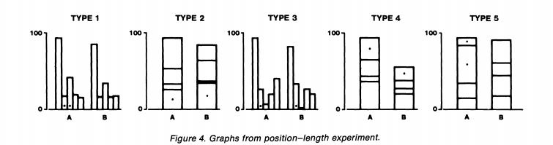Based on Cleveland and McGill’s results I think my visualization embodies good practices, where it’s goal is to compare different creative minds, how they work and how they live. By vizualizing the bars under each other, you can compare them quite good. Also de color help you with distinguishing the different people.

1. Yes, I think this visualization is a functional art. It’s a bit like Piet Mondriaan, who painted different rectangles and squares with some colors. In figure 16 of the article of Cleveland an McGill the position-length is discussed of bar-charts. My visualisation is not really a bar-chart but it is also visualized with bar’s.
2. Tasks that help you to interpret this visualization are position along a common scale, length and color, as also explained above. Especially the division of time and the length of a particular activity are important and I think it’s visualized quite clear in this image. Maybe more information about the activities, so more in depth or a story about the activities would have been nice.